**Google maps system design**

**Requirement** : how do we design a navigation application like google maps

**Lets go over some functional and non functional requirement**

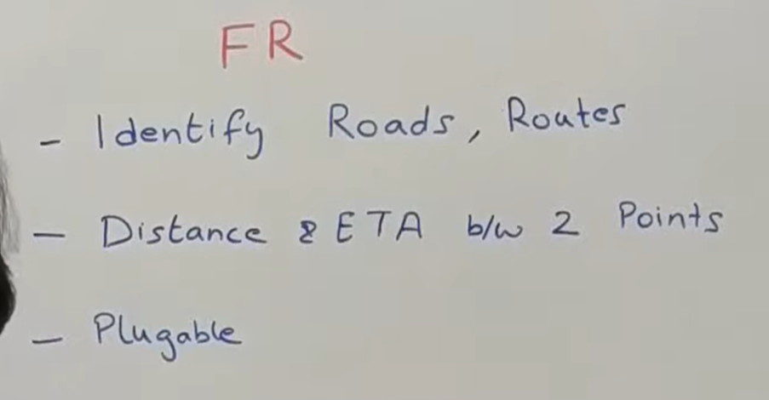

So the very first thing when a person want to move from point A to point B this platform should be able to give them a **couple of information.**

1. What is the route they should follow.
2. Given the route how much distance they have to cover and how much time it will take.
3. It should have a very pluggable model. It we want add information about weather or accident or construction or road blockage somewhere it should have very easy way to input this data and not make change in whole of the architecture.
4. How do we identify roads so there are two three ways in which we can identify new roads.

One very basic way to ask the government sources to give us all the information about all the roads data that they have. **Mainly we will focus how we can efficiently find the route between two point**

**NFR**

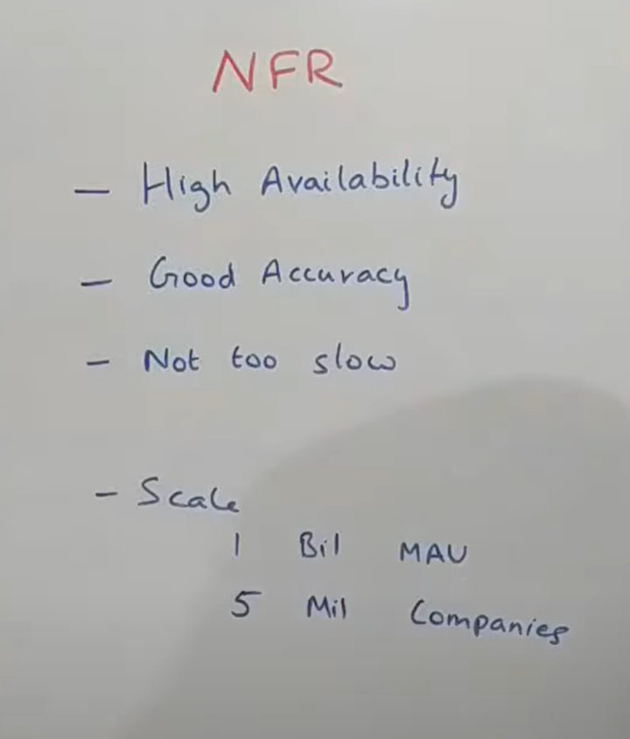

The system should always be available.

Good accuracy : should tell good route

Not too slow

**Scale :**  google map have roughly billion ( monthly active user)

There are also 5 million companies which uses google maps like uber who are using with the navigation and ricing system.

**Now building this navigation app is a very hard problem to solve not because of kind of algorithm we use but more because of kind of requirement this has.**

For example : if we try to calculate number of roads in the world there are various theories which u come up with various numbers. There are approx 50 million road. Now if we try to model it as a graph it would probably have somewhere close to 50 million vertexes and may be hundred of million of edges so that is very massive data. Now lot of company don’t have even access to this kind of data wherein what road is connecting from where to where. That kind of information is non existent in the world and there is no single point where we can fetch that which makes it very hard problem to build an navigation system like this. The next thing is , it is very hard to even quantify a lot of attributes that will impact the ETA ( estimated time arrival) . For example : **weather condition , road quality** . things like this are very hard to quantify so there is not a very easy mathematical formula that u can come up with to calculate the ETA that will required to cover a particular distance. One more challenges there could be accident somewhere , there could be road closure for any reason and those things are not really predictable and that’s the reason why lot of companies not to able to build this system successfully.

We will be using ideology of dynamic problem while we try to solve this problem. Basically we will try for small area, then for larger area and then across cities and then countries and so forth.

**Let understand the concept of segment (**  not industry standard term)

Segment : small area (like 1km)

Let say we have city will divide a city into multiple segment. So what we will try to do it each user will try to map it to some segment basis their coordinates. Now one good about these segment is because these are function of lat-long we should easily be able to identify some approximate distance b/w two segments.